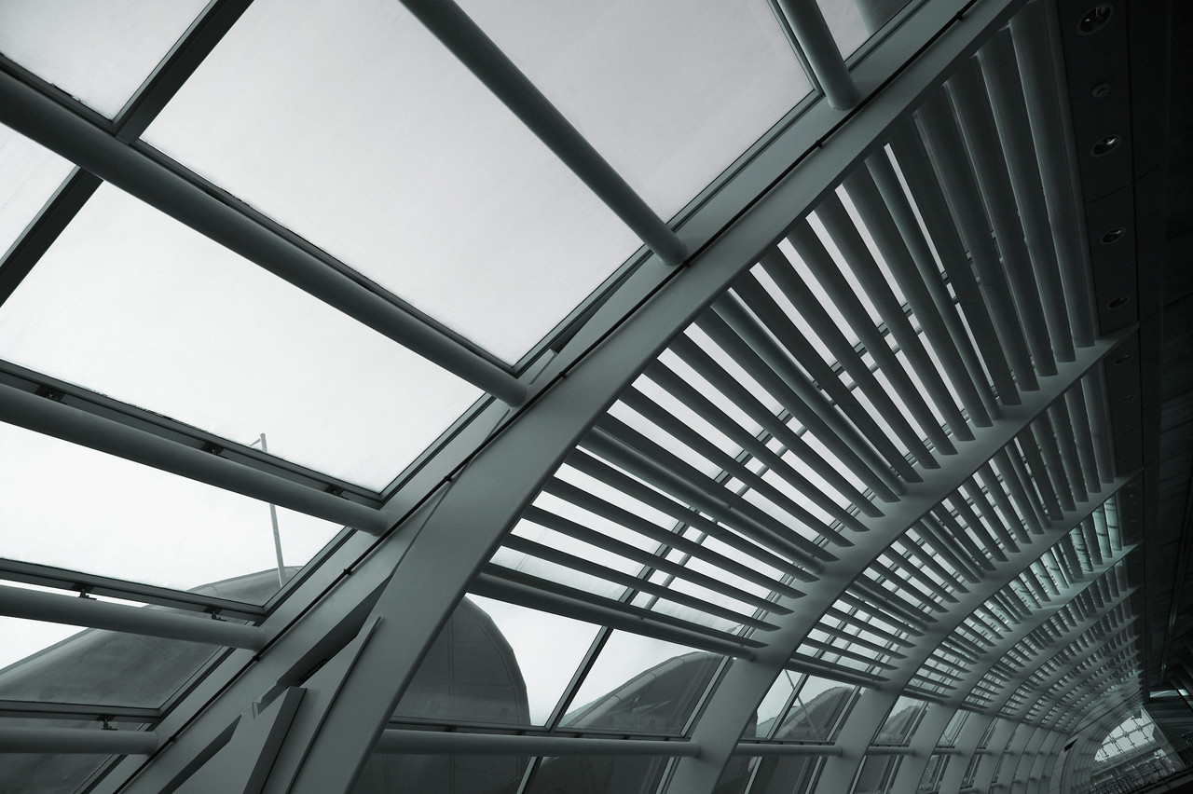

4/16/2014

Olujide Jacobs & Donna Jackson

Final Project Report - Simulating an Elevator

Cpe 311 – 003

**Introduction**

There is absolutely no doubt about the drastic development in technology these days. In earlier times, elevators used to be powered by hands or by animals but due to the increase in technology, it is now easy to go to your desired floor with just the push of a button or two. In this project, my partner and I have successfully been able to design and demonstrate the simulation of a modern day elevator. This elevator we’ve designed will be able to respond to a user’s call for it, move only when there are pending calls for it, pick a user and asks for the floor he/she is going, take a maximum of just 3 people, takes 2 seconds to move through each floor, drops off a user at their desired location and tells them what floor they are on. We didn’t choose this project, it was the only one assigned by the instructor.

**Hardware Description**

To complete the elevator design, some hardware equipment was required. The main equipment was the SBC alongside with the Breadboard where we had our LEDs, wires, pushbuttons and resistors. The SBC pins were connected to the corresponding ports on the pushbuttons, then we had wires going from the pushbuttons to the LEDs, which were connected to the resistors (1.9k). The top left areas of the pushbuttons were connected to the resistor and then to power while the bottom left area of the pushbuttons were connected to ground. We had red LEDs indicating the downward movement of the elevator, green LEDs indicating the upward movement of the elevator and yellow LEDs indicating which floor the elevator stopped at. This circuit was built on the breadboard and connected to the octagon board, which was also connected to the PC in order for it to function. A circuit picture can be seen on the next page.

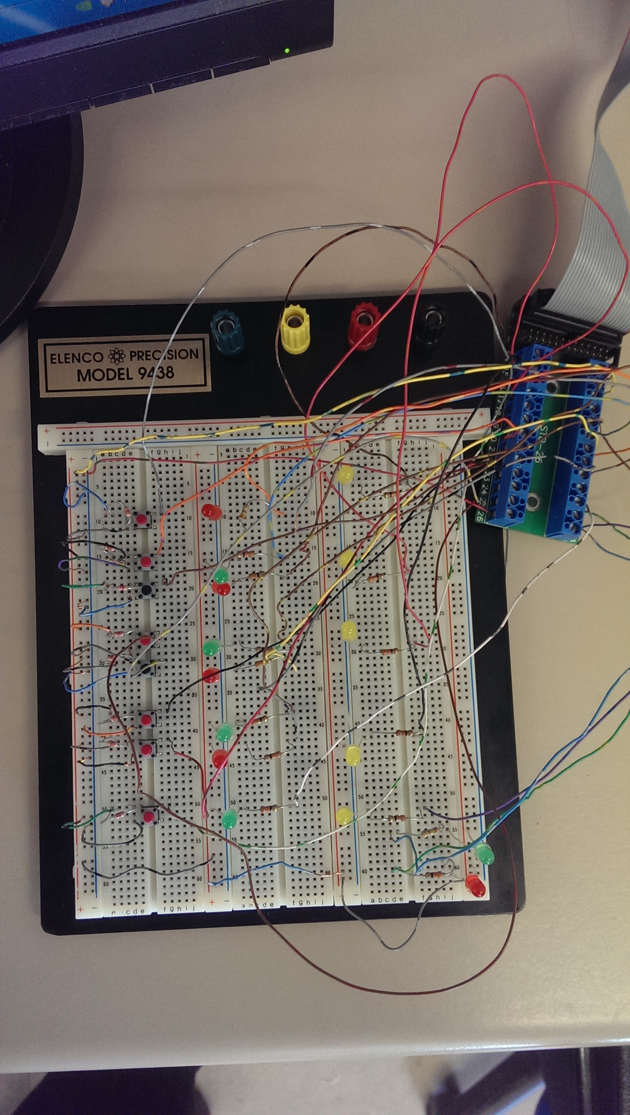

**Software Description**

This was the most essential and difficult part of the project. Without this part, the hardware build-up won’t function. This part involves all the codes and what each section of code does. Each section of code and its function(s) can be seen in the link below along with the flow chart.

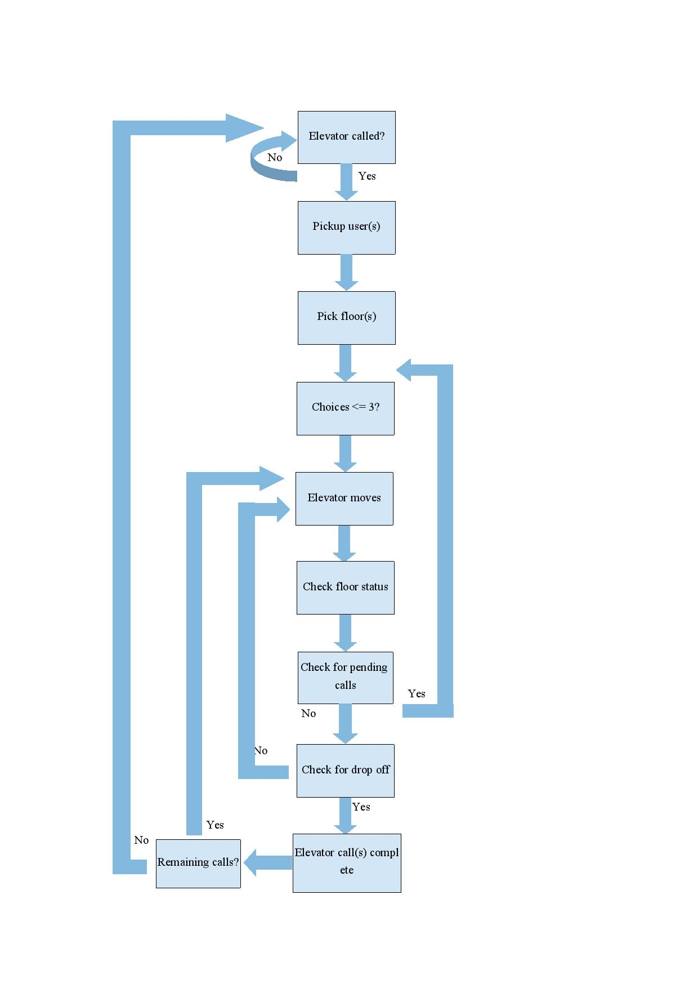

**INSERT CODE LINK**

**Problems and Solutions**

We encountered a lot of problems during the course of this project. The initial problem we had knowing how the elevator system worked. We were able to figure this out by drawing out a flow chart of the elevator system to help us better understand what our code was supposed to do. In the process of writing the code, we also encountered compilation problems. We had to search online for these errors and how to fix them. Some of our errors were also due to typographical mistakes. After finishing the code, another problem we encountered was getting the LEDs to turn on, but this was a minor problem. The problem was with the station in which we were experimenting. We moved to a new station and configured the right ports, and we were able to get the desired results.

**Conclusion**

This project was a lot of fun regardless of how complicating it was and the problems we came across but now, my partner and I fully understand the simulation of an elevator and can demonstrate it at anytime. The instructor gave helpful tips that helped with the simplicity of the project.

**Appendix: Pin mapping of the breakout board**

